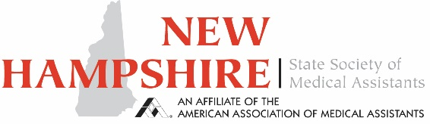

NHSMA Regional Ambassador Program

One of the innovations NHSMA has brought to the American Association of Medical Assistants is our Ambassador Program. Although we are a small state, each region has it’s own flavor, unique issues and needs. The Ambassadors work hand in hand with the Executive Board to bring issues to the board’s attention as well as helping to plan CEU sessions and Community Relation Projects in their area.
As an ambassador of your region, you would be the point person for Medical Assistants in your area. Information, concerns, or feedback you receive from you regional peers can be brought to the NHSMA board members through your voice. We also will look upon your voice to help us with conference preparation, helping to plan CEU opportunities and Community Relation Projects, and any other initiatives we investigate in order to help Medical Assistants all though the state of NH grow.
As we are always looking for additional voices to move our work forward, I would like to invite you to consider becoming an Ambassador for the NHSMA.
The Board will help by providing you with a mentor and open communication with our Ambassadors. We ask that you participate in as many board meetings as you can. This can be done in person, electronically or by phone. We are a very flexible and informal group. Ideas flow easily and are always encouraged.
If you have questions and would like more information, please contact us on our website. We would love to hear from you. If fact, if you have an idea to share or a question, we are always happy to hear from our members. All members are invited to the board meetings. Don’t forget to check out our website: NHSMA.org and the NHSMA Facebook page.

Document updated: 2/9/2021

